Major categories that make up the General Fund expenditures include: Salaries & Wages (37.8%), Fringe Benefits (14.6%), Services & Materials (9.6%), Other Operating (9.6%), Capital Outlay (0.3%), and Balances and Transfers (28.1%).

The City’s future will be shaped by the strategic goals of our neighbors and City Commission through their planning process. In the past decade, expenses have steadily trended upward due to the City’s increase in population demand for services and costs of supplies and services. To keep in line with shrinking the size of government the City has eliminated 238 full time positions, since FY 2008. Due to current conditions, City Management has implemented a policy to reduce discretionary spending.

A description of each expenditure category as well as a discussion and outlook over the next five years follows.

Salaries & Wages

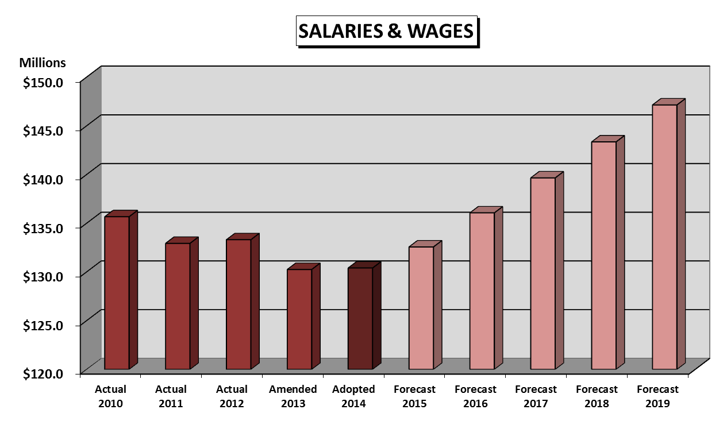
This is the largest expenditure category and represents 45.9% of all General Fund expenditures, excluding balances and reserves. The adopted expenditure for FY 2014 is $130,407,509, which represents a .1% increase from the FY 2013 amended budget. The major expenses in this category include the following: salaries, other wages, overtime, and longevity.

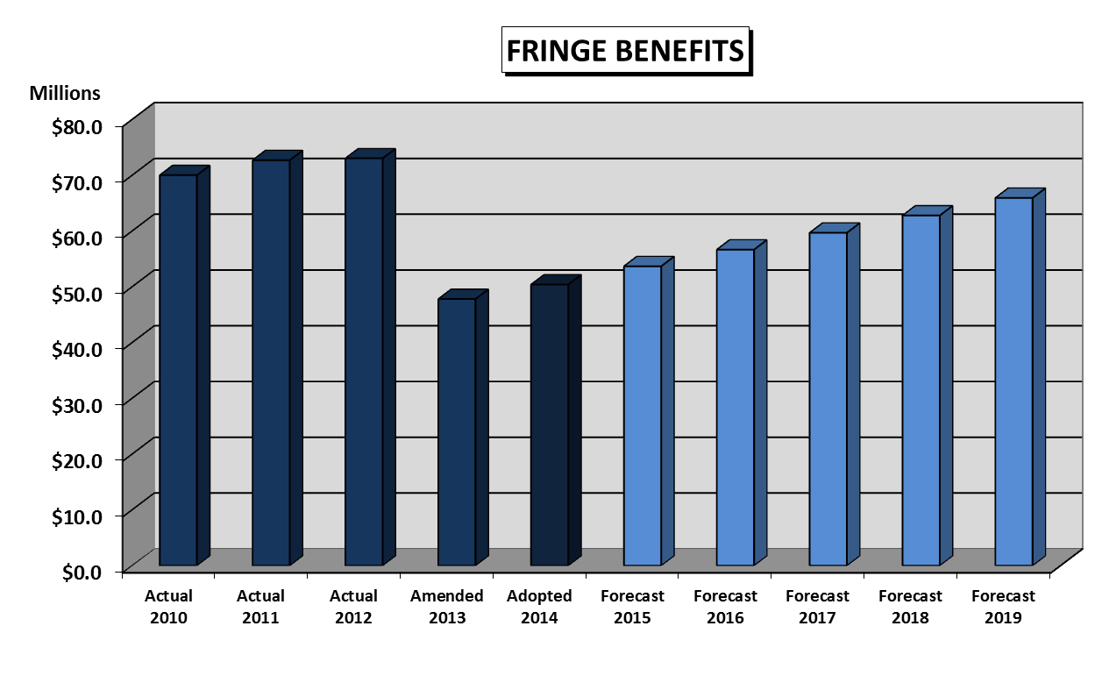
Fringe Benefits

This expenditure category includes pension, social security, health care, and retiree health care. The adopted expenditures for FY 2014 is $50,414,980, which represents a 5.5% increase from the FY 2013 amended budget, primarily due to insurance premiums. The projection includes a 6.6% annual increase over the five years.

Services & Materials

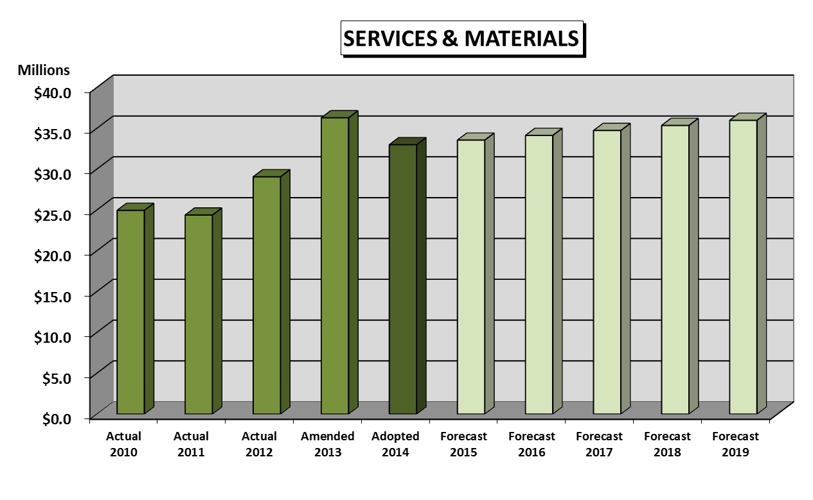
This expenditure category includes electricity, gasoline, supplies, equipment, other services, and other utilities. The adopted budget for FY 2014 is $32,997,699, which represents a 9.1% decrease from the FY 2013 amended budget. For FY 2014, Emergency 911 Call Center costs have been removed due to the new integrated Broward County regional system, which will provide county-wide services. Over the next five years, the projection is a stable inflationary factor of 1.0% for inflation of sensitive items.

Other Operating Expenditures

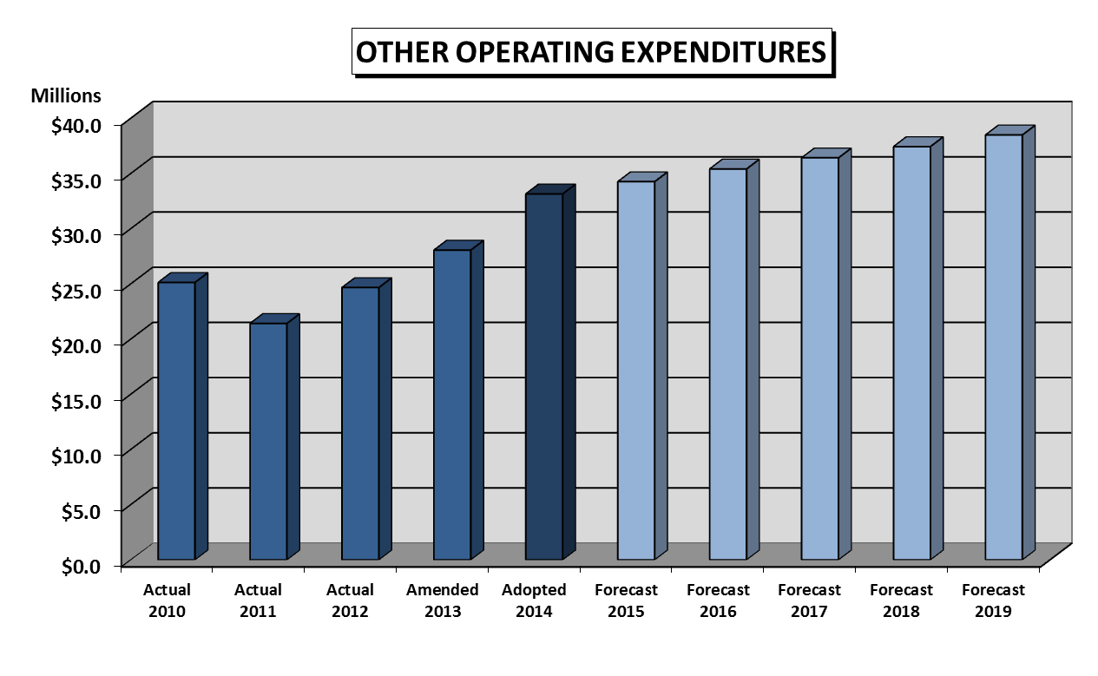
This expenditure includes liability and property insurance premiums, interfund service charges, fleet related operating and maintenance, fleet overhead, and fleet replacement charges. The adopted budget for FY 2014 is $33,093,207, which represents an 18.2% increase from the FY 2013 amended budget, which is primarily due to increases in the cost of information technology, city-wide cost allocation charges and fleet related charges.

Capital Outlay and Debt Services

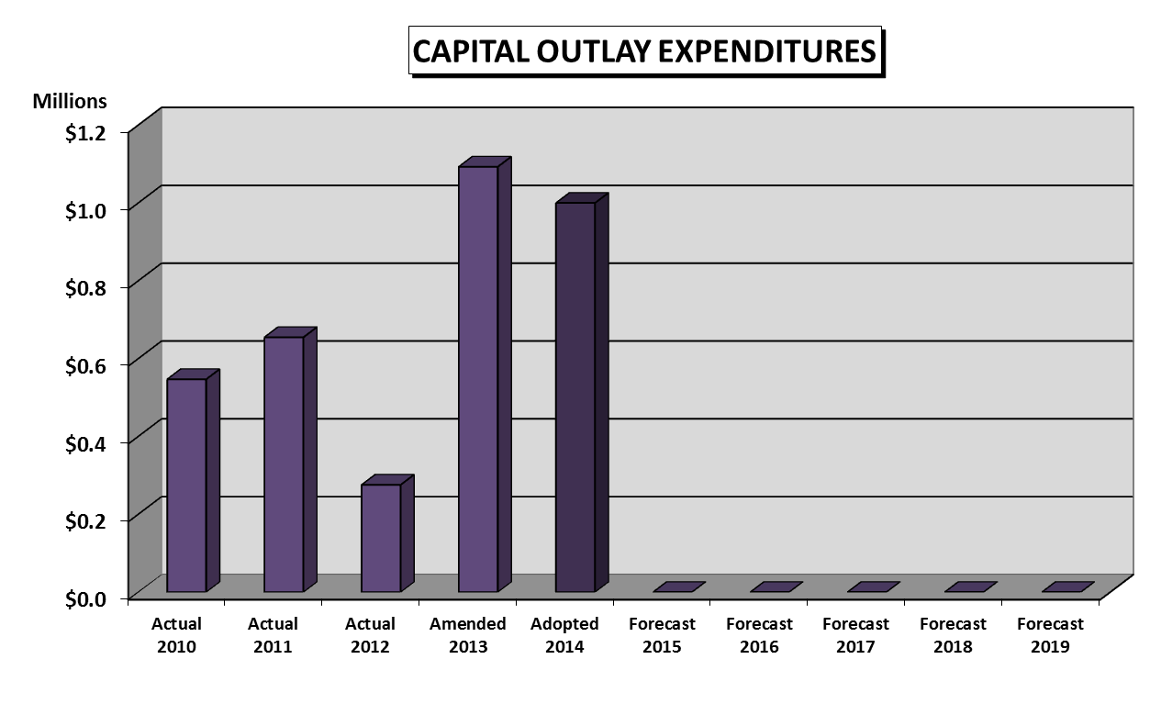
This expenditure category includes a combination of expenditures that represents $1,000,000, which is 0.4% of the General Fund expenditures. In FY 2013, a payment was made for the interest on a short term loan in the amount of $351,167.

